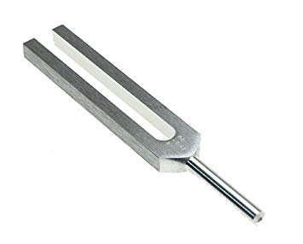
Producing Sound

Materials
You will need a tuning fork, a petri dish, a rubber band, a block of wood, a small eraser, a 30 cm ruler and a test tube.

Part 1
Strike a tuning fork on the heel of your shoe. Hold it close to your ear. What do you hear? _____________________________________________________ ________________________________________________________________

What happens when you dip the tip of a prong of the fork into some water?
________________________________________________________________________________________________________________________________________________________________________________________________

Hold this piece of paper with your thumb and forefinger so that it hangs freely. Sound the tuning fork again. Hold the fork with the prongs horizontal and just touching the paper. What do you notice? ________________________________________________________________ ________________________________________________________________________________________________________________________________

Part 2
Stretch a rubber band over a wooden block and place an eraser between the rubber band and wooden block closer to one end than the other. Gently pluck the rubber band on one side of the eraser then the other. What do you notice about the two sounds? ________________________________________________________________________________________________________________________________________________________________________________________________________________________________________________________________

Draw a diagram to show how you produced sound with the rubber band.

Part 3
Place a ruler over the edge of your desk and hold the desk end firmly. What happens when you push the other end down a short distance and then let go? How can the sound produced be changed? ________________________________________________________________ ________________________________________________________________________________________________________________________________________________________________________________________________

Draw a diagram to show how you produced sound with the ruler and what you did to change the sound.

Part 4
Blow over the end of an empty test tube. Half fill the test tube with water. What happens to the note produced? ________________________________________________________________ ________________________________________________________________________________________________________________________________________________________________________________________________

Conclusions
What do you need to produce a sound? ________________________________________________________________ ________________________________________________________________________________________________________________________________________________________________________________________________

Describe how you can change the sound that is produced. ________________________________________________________________ ________________________________________________________________________________________________________________________________________________________________________________________________

